Chris Morgan - Daniel Davieau - Steven Cocke

Introduction

For this effort we will be examining a boxing data set that includes data on boxers competing in a boxing match and will attempt to predict the outcomes of the match. The data was accessed through Kaggle, and was previously webscraped from <http://boxrec.com/>. For simplicity sake, our models were tested with a 80/20 train/test split throughout the paper as the group felt we had a reasonably large dataset that would allow this even after filtering out unusable data. R was used for prepping the data and performing all model development excluding logistic regression development, which was completed in SAS

Data description

The dataset can be found at <https://www.kaggle.com/slonsky/boxing-bouts/home> and contains the following data. Because we are trying to predict the outcomes of the match before it commences, we will be eliminating decision related data from judges as there is not a way to tie historical data to fighters within this dataset.

|  |  |
| --- | --- |
| **Variable** | **Description** |
| Age | Years – age of the boxer |
| Height | Centimeters – height of the boxer |
| Reach | Centimeters – reach from one hand to another |
| Stance | Orthodox/Southpaw |
| Weight | Pounds – weight of the boxer |
| Won | Number of past wins |
| Lost | Number of past losses |
| Drawn | Number of past draws |
| KOS | Number of wins by knockouts |
| Result | Result of the bout – win_A/win_B/draw |
| Judge[1,2,3] | Judges scores for certain boxers |

|  |  |  |
| --- | --- | --- |
| **Variable** | **Possible Value** | **Description** |
| Decision | SD | Split decision |
| Decision | MD | Majority decision |
| Decision | UD | Unanimous decision |
| Decision | KO | Knock out |
| Decision | TKO | Technical knockout |
| Decision | DQ | Disqualification |
| Decision | RTD | Retired between rounds |

Exploratory PCA

Principal component analysis was performed in the early stages of the project, but unsurprisingly given the nature of the sport of boxing, we see a heavy overlap for all of our plots. This could be an early indicator that while some variables may be able to influence the outcomes, there will be a heavy dose of randomness and outcomes will likely not be decided by singular variables.

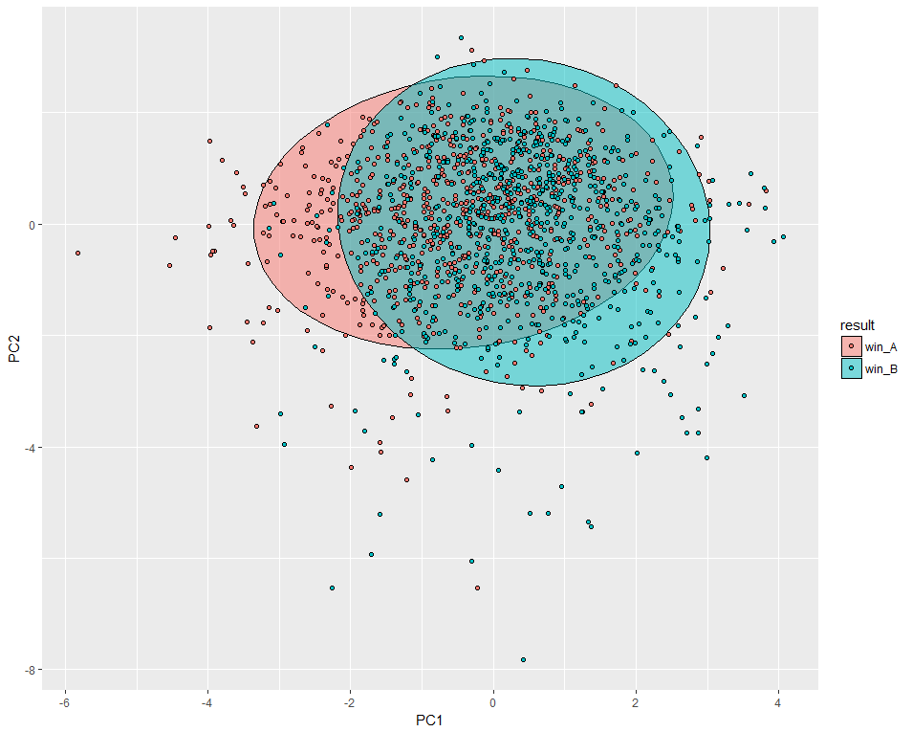 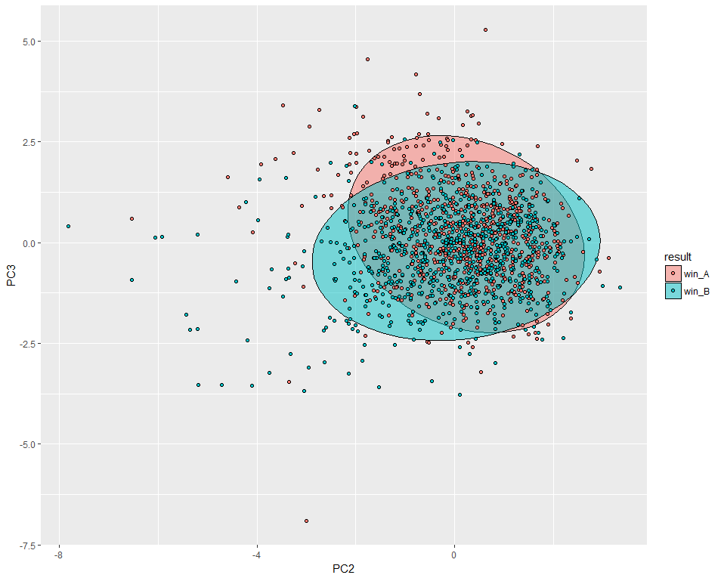

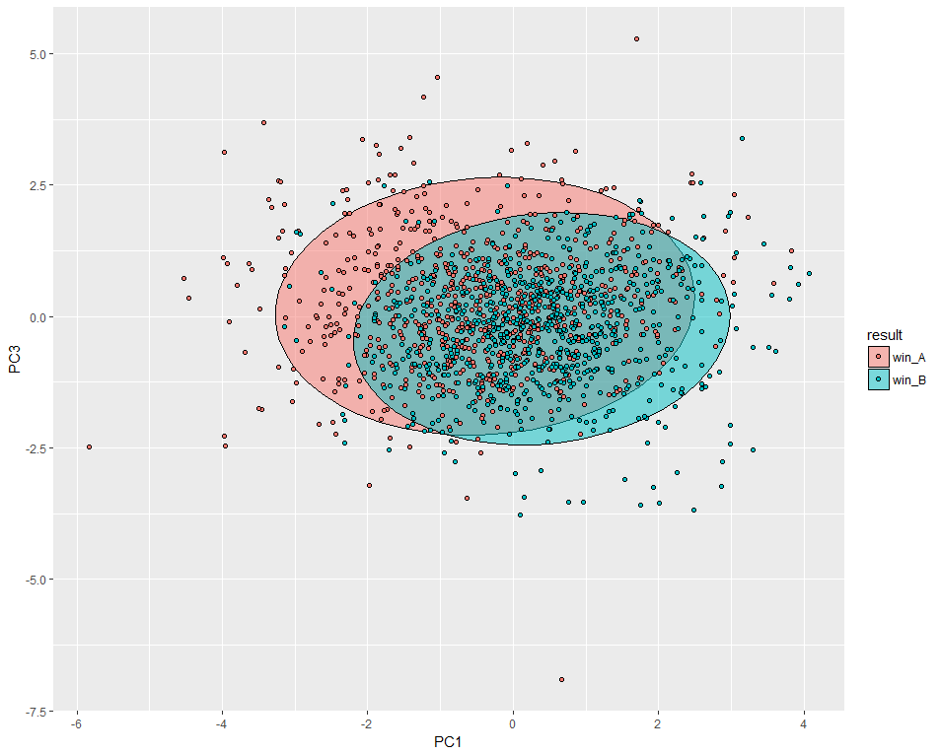

Logistic Regression Model Selection

Using trial and error (Forward, Backward, Stepwise variable selection) the best selection criteria were identified using stepwise:

/* Simple Model Selection (Without Interactions) */

/* Stepwise */

**PROC** **logistic** data= boxing;

class Stance Over35AgeA Over35AgeB Over15lbA Over15lbB;

model binaryresult = age_A age_B height_A height_B reach_A reach_B weight_A weight_B won_A won_B lost_A lost_B kos_A kos_B

/ selection = stepwise;

output out=boxinglogregout predprobs=I p=probpreb;

**run**;

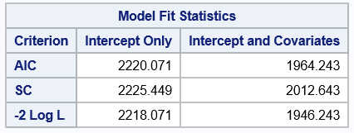

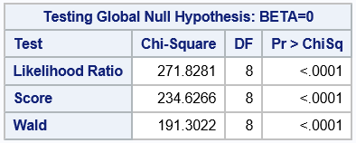

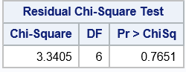

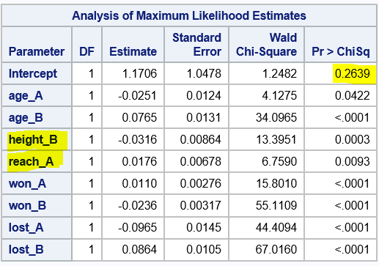

Goodness of Fit

Though the model that stepwise selection chose with lowest AIC and BIC fits, it doesn’t quite make sense that the stepwise selection includes height_B and reach_A. These variables have equal meaning and weight for each fighter. If we simply swap a and b from left to right the results would be different for no logical reason.

This could be indicating that there is indeed a difference in the meaning of the fighter_A and fighter_B slots (i.e. challenger versus incumbent). However, we have no context or documentation to confirm this. It is more likely that there is interaction between the variables.

Trial and error shows that adding age_A does not help. Removing age_B gives us statistically significant coefficients but reduces fit.

When we remove the variables altogether the fit statistics aren’t quite as good but the model makes more sense, the coefficients improve and the intercept becomes statistically significant.

|  |  |
| --- | --- |
| **Add height_A and reach_B:** | **Exclude height_A&B and reachA&B** |
|  |  |
|  |  |

Residual Diagnostics

Below is an initial plot of the observation number vs. the Pearson residual. The circled points are observations under investigation.

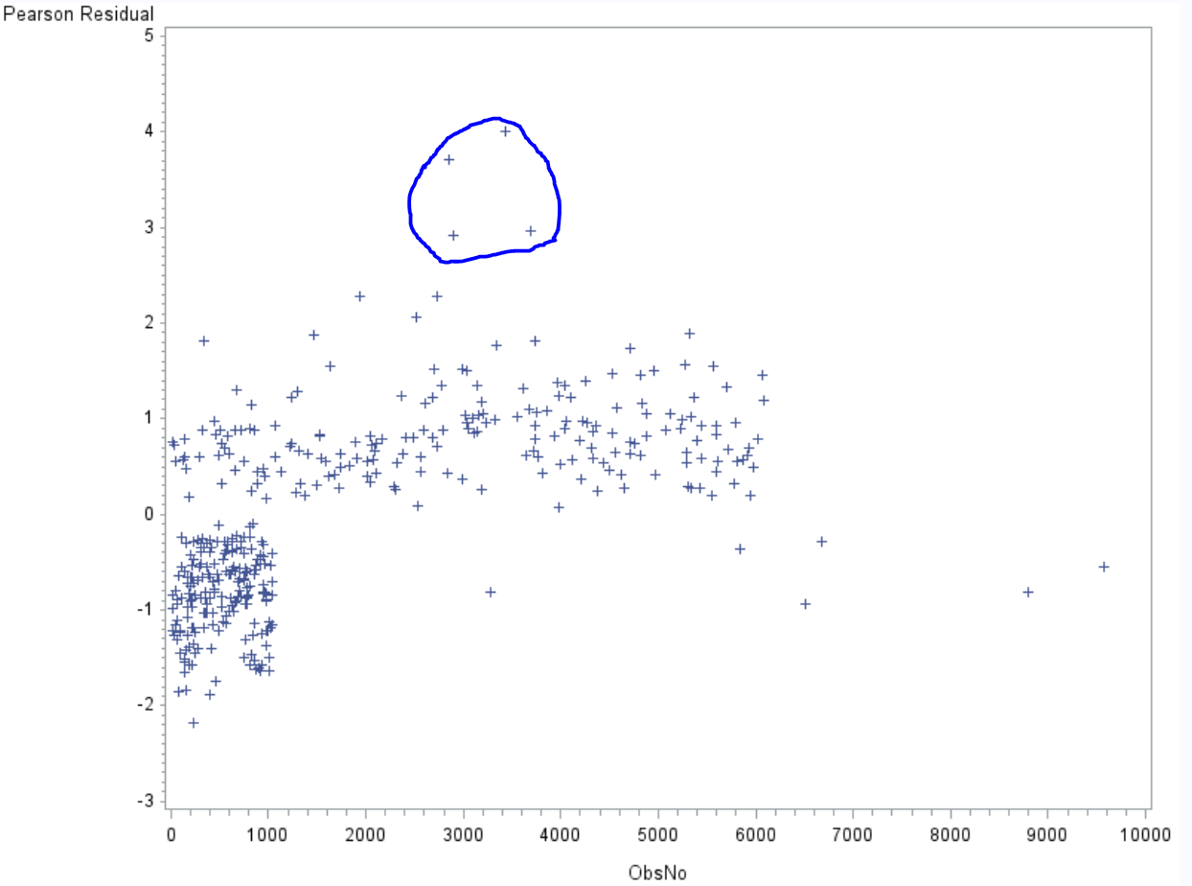

Below are some leverage diagnostics and predicted probability plots. The same 4 points are highlighted in both plots as potential outliers.

The observation numbers are 634, 1438, 523, 560

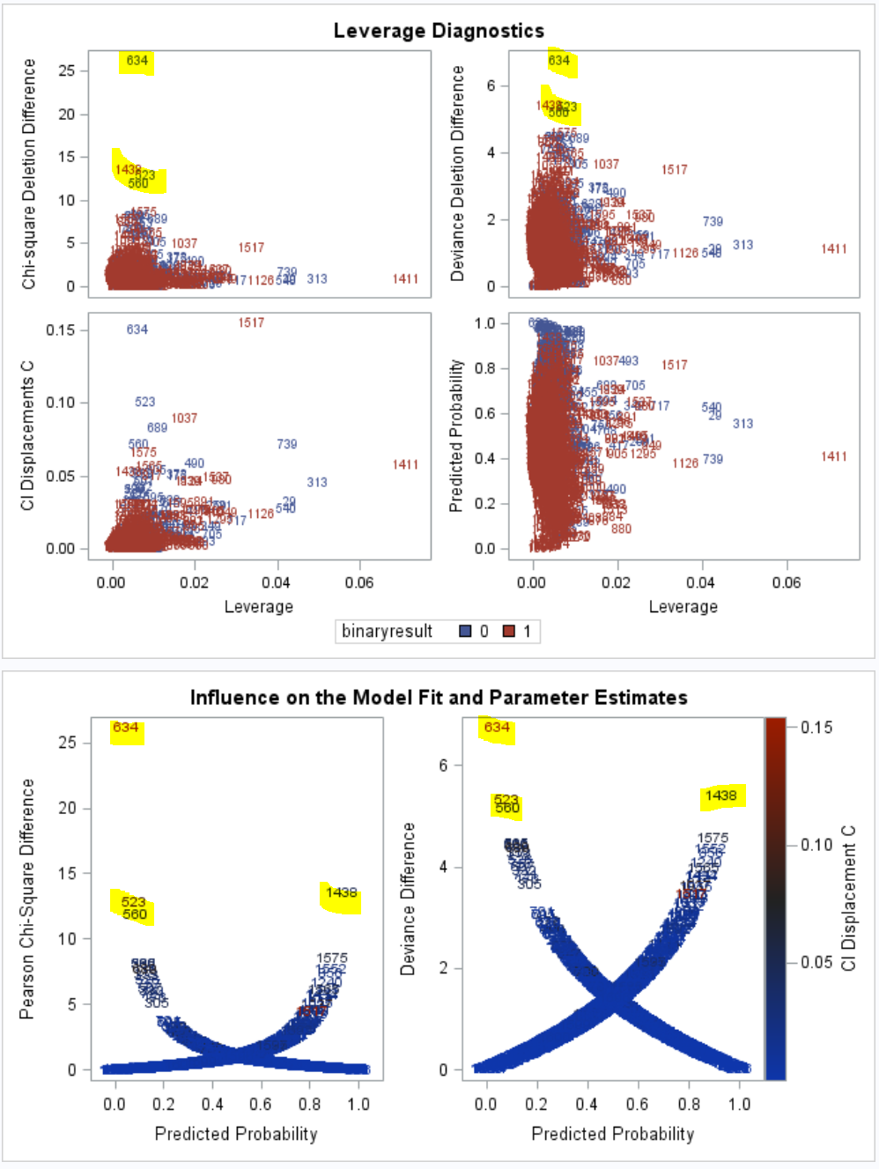

Suspicious outliers;

* Observation No. 1438 age_A=23 vs age_B=32 seems extreme.
* Observation No. 634 reach_A=191 seems extreme.

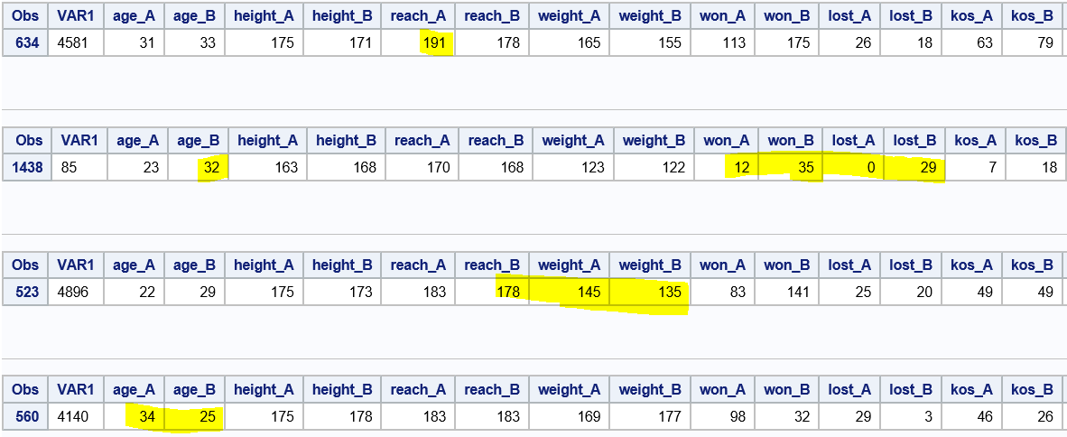

As a test, we removed the 4 outliers stated previously, and reran the model fit. The outcome is displayed below. The significance improves, as does the AIC score. We will choose the final model as the one without the outliers present.

|  |  |
| --- | --- |
| With Outliers | Without Outliers |
|  |  |

The Chosen Model

Common sense tells us that there is almost certainly interaction; however, **for the purpose of part 1 in this analysis we will not include an interaction terms as instructed.**

/* Chosen Model with a touch of common sense */

**PROC** **logistic** data= boxing plots(only label)=(leverage dpc);

model binaryresult = age_A age_B won_A won_B lost_A lost_B /LACKFIT CTABLE;

output out=boxinglogregout predprobs=I p=probpreb resdev=resdev reschi=pearres;

We can reject the null hypotheses that BETA=0. Our variables are statistically significant in predicting 0,1 Fighter A Wins versus Fighter B Wins

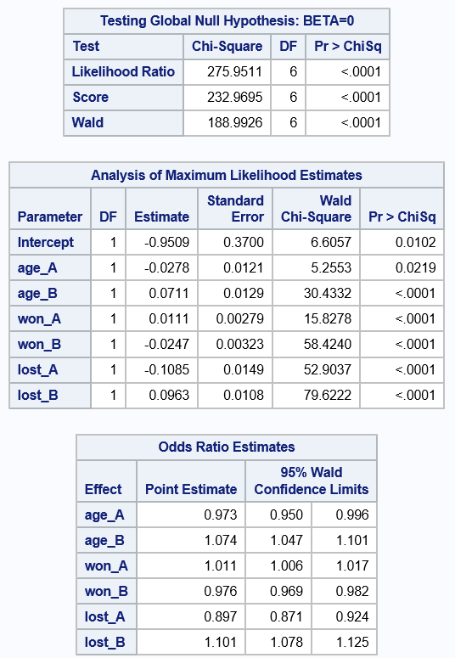

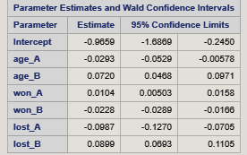

An examination of our confidence intervals shows that predictors are all staying positive or negative, but not value has a completely standout prediction value. This seems to indicate that we have a decent model that is being predicted without any incredibly strongly influencing predictors. This is a bit counterintuitive given that some of our predictors have very low p values, but this is likely an indication of less practical strength of the predictors over there significance levels.

We use Hosmer Lemeshow to test the model accuracy in prediction because there are many continuous variables.

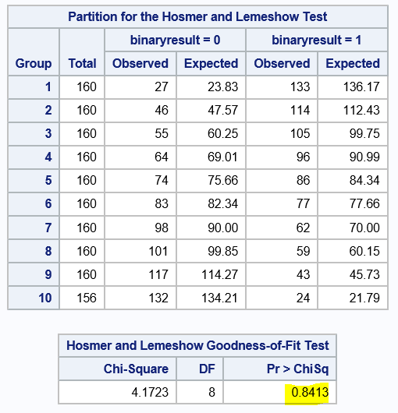

We do not reject the null hypothesis because the p-value is .8413 (highlighted above); we conclude that the model is a good fit.

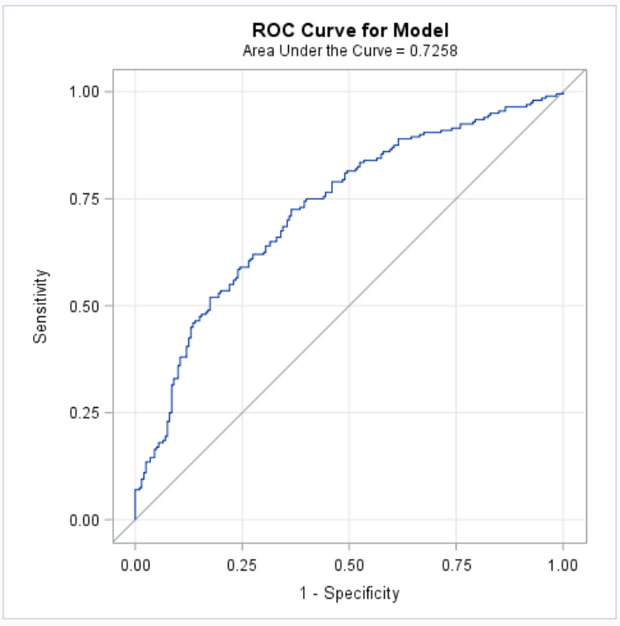

Our ROC curve does show reasonable predictive strength for our training model with a 0.72 area under the curve

Logistic Model Equation

To properly understand this we will provide an example that is a bit of a mismatch in favor of A, resulting a probability of 0.8765 in favor of boxer A winning by sampling plugging into the above formula.

|  |  |  |  |  |  |  |
| --- | --- | --- | --- | --- | --- | --- |
| Coeficient | AgeA | AgeB | WonA | WonB | LostA | LostB |
| na | 25 | 50 | 20 | 2 | 10 | 10 |
| -0.9509 | -0.0278 | 0.0711 | 0.0111 | -0.0247 | -0.1085 | 0.0963 |

A more complex Logistic Model

As an attempt to improve our prediction strength, we will attempt to perform some variable creation

As an attempt to examine the effects of the effects of a fighter’s “advantages” over there opponent we created advantage variables to study how powerful an advantage of age, arm length, height, weight might be (which were named AdvAgeA, AdvHeight,AdvReach,and AdvWgtA respectively). Each variable was created

Creating a new variable “AdvAgeA” as Age_A – Age_B accounts for both variables an allows us to model without an interaction term. Interestingly it actually has slightly better fit statistics than the interaction term. The fit statistics aren’t quite as good as what stepwise selection gave us but the model makes more sense.

Binary variables were also created to test factors that we were hypothesized might have some predictive power, such as if each fighter was over 35 or if there was greater than a 15 lb. weight differential. These variables represent Over35AgeA, Over 35AgeB, Over15lbA, and Over15lbB

We have created a win percentage for each fighter as WinPA & WinPB. This has also been done with KO percentages with KoAPer & KoBper

Performing a stepwise selection, our model shows the following output showing that our new variables are being utilized appear to be significant

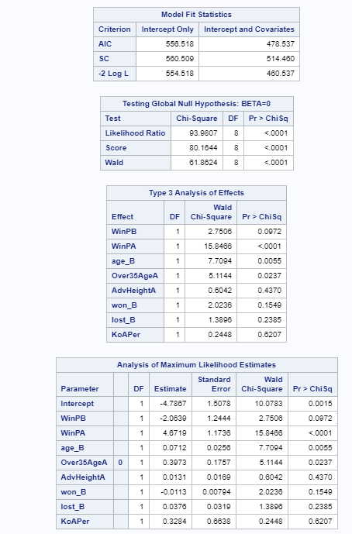

To test improvement, we run the new model with our test data and we see some modest improvements to our apparent predictive performance improving from an AUC of .72 to .74, so our created variables appear to have slightly improved our model performance.

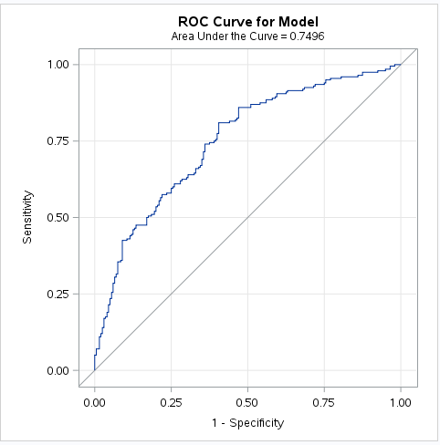

LDA Model

To compete with our logistic regression, an LDA model was developed with all continuous variables resulting in the following LD coefficients:

> lda.fit<-lda(binaryresult ~ ., data=dfldatrain)

> lda.fit

Coefficients of linear discriminants:

LD1

age_A 4.143902e-02

age_B -9.640704e-02

height_A -1.089003e-02

height_B 3.356029e-02

reach_A -2.122836e-02

reach_B 4.180252e-03

weight_A -6.058746e-05

weight_B 3.002786e-03

won_A -9.309674e-03

won_B 3.156529e-02

lost_A 7.708957e-02

lost_B -8.440838e-02

kos_A -3.180615e-03

kos_B -1.223608e-02

These resulted in the following confusion matrix showing similar performance levels:

|  |  |  |  |
| --- | --- | --- | --- |
|  |  | Actual (random forest CM) | |
|  |  | Fighter A Wins (0) | Fighter B Wins (1) |
| Predicted | Fighter A Wins (0) | 141 | 63 |
| Fighter B Wins (1) | 59 | 137 |

Examing the ROC curve below shows that we are performing similarly to our more complex logistic regression model.

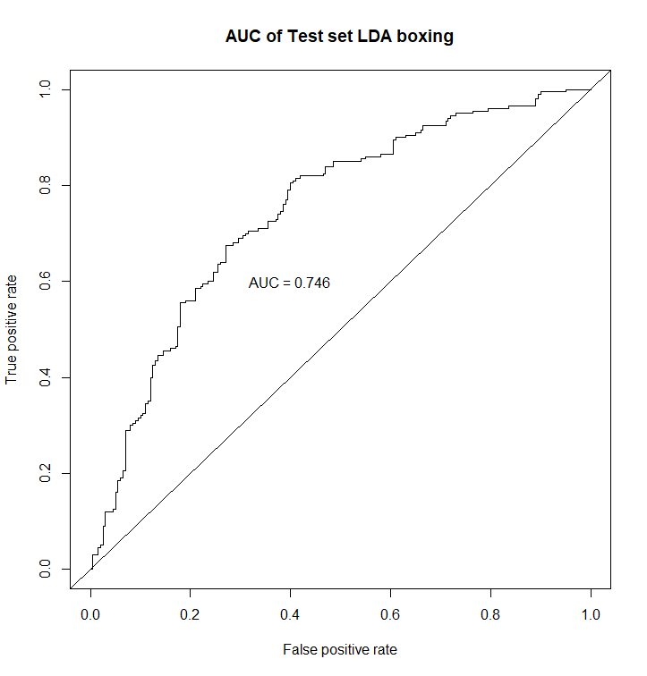

Random Forest

To compete with our logistic regression model, a random forest model was developed for our boxing data set.

To help improve our “mtry” settings of variable sampling, the “tuneRF” function was utilized to test different model performances at different levels:

> bestmtry<-tuneRF(x = dftrain[,-27],y=dftrain[,27],stepFactor=1.5, ntree=400)

mtry = 5 OOB error = 30%

Searching left ...

mtry = 4 OOB error = 29.69%

0.01041667 0.05

Searching right ...

mtry = 7 OOB error = 30.56%

-0.01875 0.05

> print(bestmtry)

mtry OOBError

4.OOB 4 0.296875

5.OOB 5 0.300000

7.OOB 7 0.305625

This returned a lowest OOB error value for 4 mtry’s. Multiple runs were conducted with little variation so 4 mtry’s were utilized. Multiple iterations were run at different ntree levels as well, but little variation was seen beyond 400 ntree’s, which may be asymptomatic of the small effective data size after cleaning the dataset.

> rf.box <- randomForest(x = dftrain[,-27],y = dftrain[,27],mtry=4,ntree = 400,importance = T)

> rf.box

Call:

randomForest(x = dftrain[, -27], y = dftrain[, 27], ntree = 400, mtry = 4, importance = T)

Type of random forest: classification

Number of trees: 400

No. of variables tried at each split: 4

OOB estimate of error rate: 29.31%

Model Characteristics

An examination of our random forest model shows that win percentage for each fight appear to have the highest scores for our model, but unfortunately there are no other standout predictors and our interpretability of a random forest model is somewhat limited.

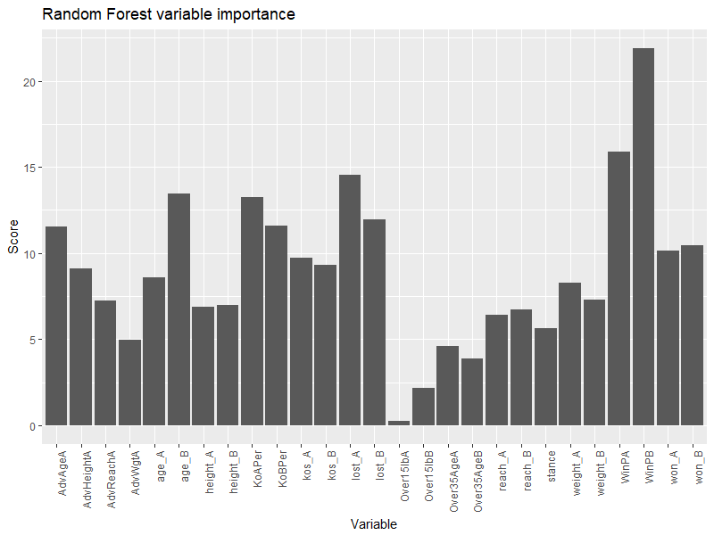

Testing the dataset with an 80/20 split of our data shows the following confusion matrix and modest predictive performance:

|  |  |  |  |
| --- | --- | --- | --- |
|  |  | Actual (random forest CM) | |
|  |  | Fighter A Wins (0) | Fighter B Wins (1) |
| Predicted | Fighter A Wins (0) | 138 | 62 |
| Fighter B Wins (1) | 59 | 141 |

This also yields the following ROC curve which is slightly more promising and appears to show a modestly good predictive power.

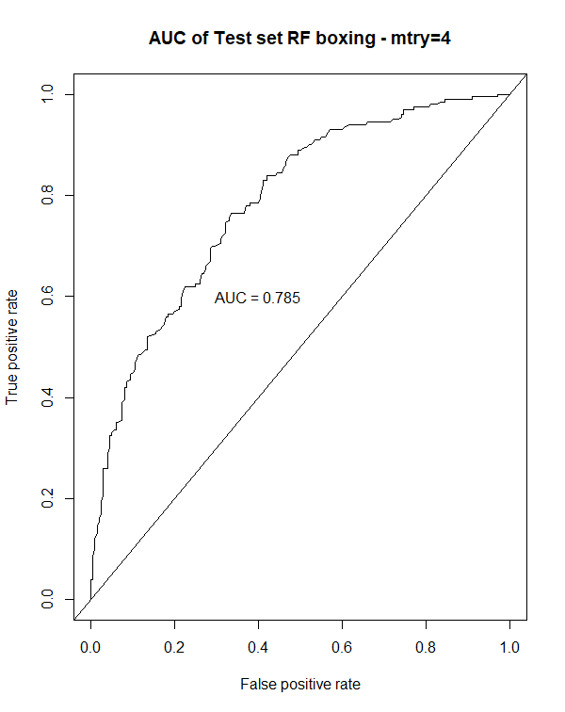

Conclusion

After examining logistic regression with and without additional variables, LDA, and random forest modeling techniques, it appears that the random forest model offers the strongest predictive power for our data set by a somewhat narrow margin. This can be seen by examining the correct prediction performance through each of our tests, but we’ve summarized below using the AUC as a key reference metric (although AUC should never be the sole selection criteria).

Because of the nature of boxing (and any sport for that matter) a level of randomness will always be present. The relationships and interactions of different styles and fighter strengths can be incredibly complex. This makes random forest naturally seem like a reasonable modeling tool for the task as random forest models allow for greater levels of complexity when predicting outcomes by being able to create many different trees that can come relatively close to some of the complex interactions between variables.

A fair argument could be made that with the closeness of the results that the complex logistic regression could be selected for its interpretability to the user, but given the argument of modeling the complexity of the sport, we feel it would be best to view the random forest as our best model.

|  |  |  |  |  |
| --- | --- | --- | --- | --- |
|  | **Logistic Regression** | **Logistic Regression (complex)** | **LDA** | **Random Forest** |
| AUC | .7258 | .7496 | .7468 | .785 |

SAS Code

/* Assumptions */

/* Multivariate normal distribution for entire set of variables */

/* Univariate normal distribution on response */

/* Linear relationships between scores on Y and scores on X for all variables */

/* Uniform error variances for response (Y) across all values of X */

/************************* Part 1: Simple Thoughless Model Selection Without Interactions *************************/

%***web_drop_table***(WORK.BOXING);

FILENAME REFFILE "C:/Users/danie/Documents/GitHub/6372BoxingProject/train.csv";

**PROC** **IMPORT** DATAFILE=REFFILE

DBMS=CSV

OUT=WORK.BOXING;

GETNAMES=YES;

**RUN**;

/* PROC PRINT data=boxing; */

/* Simple Model Selection (Without Interactions) */

/* Stepwise */

**PROC** **logistic** data= boxing;

class Stance Over35AgeA Over35AgeB Over15lbA Over15lbB;

model binaryresult = age_A age_B height_A height_B reach_A reach_B weight_A weight_B won_A won_B lost_A lost_B kos_A kos_B

/ selection = stepwise;

output out=boxinglogregout predprobs=I p=probpreb;

**run**;

/* Forward */

**PROC** **logistic** data= boxing;

class Stance Over35AgeA Over35AgeB Over15lbA Over15lbB;

model binaryresult = age_A age_B height_A height_B reach_A reach_B weight_A weight_B won_A won_B lost_A lost_B kos_A kos_B

/ selection = forward;

output out=boxinglogregout predprobs=I p=probpreb;

**run**;

/* Backward */

**PROC** **logistic** data= boxing;

class Stance Over35AgeA Over35AgeB Over15lbA Over15lbB;

model binaryresult = age_A age_B height_A height_B reach_A reach_B weight_A weight_B won_A won_B lost_A lost_B kos_A kos_B

/ selection = backward;

output out=boxinglogregout predprobs=I p=probpreb;

**run**;

/* Candidate 1 add the accompanying variables */

**PROC** **logistic** data= boxing;

model binaryresult = age_A age_B won_A won_B lost_A lost_B height_A height_B reach_A reach_B /LACKFIT CTABLE;

output out=boxinglogregout predprobs=I p=probpreb resdev=resdev reschi=pearres;

**run**;

/* Chosen Model with a touch of common sense */

**PROC** **logistic** data= boxing plots(only label)=(leverage dpc);

model binaryresult = age_A age_B won_A won_B lost_A lost_B /LACKFIT CTABLE;

output out=boxinglogregout predprobs=I p=probpreb resdev=resdev reschi=pearres;

**run**;

/* Analyze outliers */

**DATA** boxing;

SET boxing;

obsno=_n_;

**RUN**;

**proc** **print** data=boxing;

where obsno = **634**;

**run**;

**proc** **print** data=boxing;

where obsno = **1438**;

**run**;

**proc** **print** data=boxing;

where obsno = **523**;

**run**;

**proc** **print** data=boxing;

where obsno = **560**;

**run**;

/* Remove outliers and run again */

**DATA** boxingRemovedOutliers;

SET boxing;

IF obsno = **634** THEN DELETE;

IF obsno = **1438** THEN DELETE;

IF obsno = **523** THEN DELETE;

IF obsno = **560** THEN DELETE;

**RUN**;

/* Choose Model with a touch of common sense */

**PROC** **logistic** data= boxingRemovedOutliers plots(only label)=(leverage dpc);

model binaryresult = age_A age_B won_A won_B lost_A lost_B /LACKFIT CTABLE;

output out=boxinglogregout predprobs=I p=probpreb resdev=resdev reschi=pearres;

**run**;

/* Test Model */

%***web_drop_table***(WORK.BOXINGTEST);

FILENAME REFFILE "C:/Users/danie/Documents/GitHub/6372BoxingProject/test.csv";

**PROC** **IMPORT** DATAFILE=REFFILE

DBMS=CSV

OUT=WORK.BOXINGTEST;

GETNAMES=YES;

**RUN**;

**proc** **logistic** data=BOXINGTEST rocoptions(crossvalidate) plots(only)=roc;

model binaryresult(event="0") = age_A age_B won_A won_B lost_A lost_B;

**run**;

PROC logistic data= boxing;

class Stance Over35AgeA Over35AgeB Over15lbA Over15lbB;

model binaryresult = age_A age_B height_A height_B reach_A reach_B weight_A weight_B won_A won_B lost_A lost_B kos_A kos_B AdvAgeA AdvHeightA AdvReachA AdvWgtA Over35AgeA Over35AgeB Over15lbA Over15lbB WinPA WinPB KoAPer KoBPer

/ selection = stepwise;

output out=boxinglogregout predprobs=I p=probpreb;

run;

proc logistic data=BOXINGTEST rocoptions(crossvalidate) plots(only)=roc;

class Over35AgeA;

model binaryresult(event="0") = WinPB WinPA age_B Over35AgeA AdvHeightA won_B lost_B KoAper;

run;

R Code

library(glmnet)

library(ROCR)

library(MASS)

library(ggplot2)

library(pheatmap)

library(randomForest)

library(dplyr)

library(caTools)

library(caret)

library(ROCR)

library(reshape)

#"Retrospective Study"

#Mention the transformation issues (i.e we removed the draw observations) we did in the data. Perhaps A Wins or doesn't win. MAybe include draws.

#COnsider LDA for all 3

#Assumptions:

#Multivariate normal distribution for entire set of variables

#Univariate normal distribution on response

#Linear relationships between scores on Y and scores on X for all variables

#Uniform error variances for response (Y) across all values of X

##main file for boxing casestudy

setwd("~/GitHub/6372BoxingProject")

#read in data - may need to remove stance na values

df <- read.csv("data.csv", na.strings = c("", "NA"))

#####################filter out bad & unnecessary data ########################################################

#eliminate draw outcomes

df <- filter(df, result != "draw")

#eliminate draw history & judge data since won't function as a predictor

df <- df[, -c(15, 16, 20:26)]

#filter out missing data

df <- df[complete.cases(df[, c(1:6, 9, 10)]), ]

#filter out weird age values

df <- subset(df, subset = (df$age_A >= 16 & df$age_A <= 60))

df <- subset(df, subset = (df$age_B >= 16 & df$age_B <= 60))

#filter out weird reach values

df <- subset(df, subset = (df$reach_A >= 100 & df$reach_A <= 300))

df <- subset(df, subset = (df$reach_B >= 100 & df$reach_B <= 300))

#assign as factors

df$result <- factor(df$result)

##############################potential modeling factors for interaction effects ########################

#create age delta

df$AdvAgeA <- df$age_A - df$age_B

#create height delta

df$AdvHeightA <- df$height_A - df$height_B

#create reach delta

df$AdvReachA <- df$reach_A - df$reach_B

#create weight delta

df$AdvWgtA <- df$weight_A - df$weight_B

#over 35 age binary ###35 is the age limit for amateur boxing, some have argued limits should exist for pro's###

df$Over35AgeA <- ifelse(df$age_A >= 35, 1, 0)

df$Over35AgeB <- ifelse(df$age_B >= 35, 1, 0)

#over 15 lbs weight delta?

df$Over15lbA <- ifelse(df$AdvWgtA >= 15, 1, 0)

df$Over15lbB <- ifelse(df$AdvWgtA <= -15, 1, 0)

#win % for boxers

df$WinPA <- df$won_A / (df$won_A + df$lost_A)

df$WinPB <- df$won_B / (df$won_B + df$lost_B)

#KO per fight

df$KoAPer <- df$kos_A / (df$won_A + df$lost_A)

df$KoBPer <- df$kos_B / (df$won_B + df$lost_B)

#add binaryresult value: 0 means that A won. 1 means that B won

df$binaryresult <- ifelse(df$result == "win_A", 0, 1) #doublecheck that binary result is correct #unique(df$binaryresult)

#Recategorize the stances that are NA.

df$stance_A <- as.character(df$stance_A)

df$stance_B <- as.character(df$stance_B)

df$stance_A[is.na(df$stance_A)] <- "Unknown"

df$stance_B[is.na(df$stance_B)] <- "Unknown"

#Check to make sure NA stances are recategorized #unique(df$stance_A) #unique(df$stance_B)

#Notcied that the stance is same for A and B in all observations to keep only A and re-label it

df$stance<-df$stance_A

df<-df[c(-7,-8)]

#unique(df$stance)

#Remove any reminaing NA observations

df <- na.omit(df)

#nrow(df) result is 7135 observations

############################EDA#################################################

#Need to add histograms, box Plots, corr and cov matrices,

#DD: Clearly our data is overepresenting the scenario when a wins vs when b wins.

hist(df$binaryresult)

#Split df by category

df_A_wins <- filter(df, binaryresult == 0)

df_B_wins <- filter(df, binaryresult == 1)

#nrow(df_A_wins) shows 6094 obs where a won

#nrow(df_B_wins) shows 1041 obs where b won

set.seed(42)

#Randomly sample approx 20% of useable observations per category and combine back together

#dftrain <- rbind(sample_n(df_A_wins, 1040), sample_n(df_B_wins, 1040))

#creates randomsample

df_A_wins<-sample_n(df_A_wins, 1000)

df_B_wins<-sample_n(df_B_wins, 1000)

#creates split @80%

SplitAWin<-sample.split(df_A_wins$binaryresult,SplitRatio = 0.8)

SplitBWin<-sample.split(df_B_wins$binaryresult,SplitRatio = 0.8)

#creates training and test dataset

trainingA<-subset(df_A_wins,SplitAWin==TRUE)

trainingB<-subset(df_B_wins,SplitBWin==TRUE)

testA<-subset(df_A_wins,SplitAWin==FALSE)

testB<-subset(df_B_wins,SplitBWin==FALSE)

#creates train test

dftrain<-rbind(trainingA,trainingB)

dftest<-rbind(testA,testB)

#write.csv(dftrain, file = "dftrain.csv")

hist(dftrain$binaryresult)

hist(dftest$binaryresult)

############################PCA#################################################

#Choose continuous variables as x axis

boxing.x <-

subset(

dftrain,

select = c(

AdvAgeA,

AdvHeightA,

AdvReachA,

AdvWgtA,

WinPA,

WinPB,

KoAPer,

KoBPer

)

)

##Choose binary result as y axis

boxing.y<-subset(dftrain, select = c(binaryresult))

boxing.y <- as.factor(as.character(boxing.y))

#Scale x variables and run pcomp

pcresults <- prcomp(boxing.x, scale = TRUE)

#BiPlot shows that reach, weight and height aren't adding quite as much value as others

biplot(pcresults, scale = 0)

#Put PC Scores into dataframe

pcscores <- as.data.frame(pcresults$x)

#Combine the pc scores with variable with the df

pcscores$binaryresult<-boxing.y

pcscores<-data.frame(pcscores)

pceigen<-(pcresults$sdev)^2

pcprop<-pceigen/sum(pceigen)

pccumprop<-cumsum(pcprop)

plot(pcprop,type="l",main="Scree Plot",ylim=c(0,1),xlab="PC #",ylab="Proportion of Variation")

lines(pccumprop,lty=3)

#Combine everything into dftrain and ggplot

dftrain <- cbind(dftrain, pcresults$x)

#Need to think about this.

ggplot(dftrain, aes(PC1, PC2, col = result, fill = result)) +

stat_ellipse(geom = "polygon", col = "black", alpha = 0.5) +

geom_point(shape = 21, col = "black")

ggplot(dftrain, aes(PC2, PC3, col = result, fill = result)) +

stat_ellipse(geom = "polygon", col = "black", alpha = 0.5) +

geom_point(shape = 21, col = "black")

ggplot(dftrain, aes(PC1, PC3, col = result, fill = result)) +

stat_ellipse(geom = "polygon", col = "black", alpha = 0.5) +

geom_point(shape = 21, col = "black")

####begin random forest work#####

#drop pca & unnecessary data

dftrain<-dftrain[,c(-15,-30:-37)]

dftrain$binaryresult<-as.factor(dftrain$binaryresult)

dftrain$stance<-as.factor(dftrain$stance)

dftest<-dftest[,-15]

dftest$binaryresult<-as.factor(dftest$binaryresult)

dftest$stance<-as.factor(dftest$stance)

str(dftrain)

summary(dftrain)

colSums(is.na(dftrain)|dftrain == '')

set.seed(42)

#runs random forest

rf.box <- randomForest(x = dftrain[,-27],y = dftrain[,27],mtry=4,ntree = 400,importance = T)

rf.box

#performs OOB estimation

bestmtry<-tuneRF(x = dftrain[,-27],y=dftrain[,27],stepFactor=1.5, ntree=400)

print(bestmtry)

#use testdata

y_pred <- predict(rf.box, newdata = dftest[-27])

#confusion matrix

cm <- table(dftest[, 27], y_pred)

cm

#RF Accuracy

(138+141)/(400)

#RF Sensitivity

138/(59+138)

#RF Specificity

141/(141+62)

#creates table for randome forest variables

rf.imp<-varImp(rf.box)

rf.imp$variable<-row.names(rf.imp)

rf.imp<-rf.imp[,-1]

colnames(rf.imp)<-c("Score","Variable")

rf.imp$Variable<-as.factor(rf.imp$Variable)

#creates plot of variable importance

ggplot(rf.imp, aes(y=Score, x=Variable)) +

geom_bar( stat="identity", show.legend = F) + ggtitle("Random Forest variable importance") +

theme(axis.text.x = element_text(angle = 90, hjust = 1))

#barplot()

###end

#Go get the ROC

rf.pred<-predict(rf.box,newdata=dftest[,-27],type="prob")

pred <- prediction(rf.pred[,2], dftest$binaryresult)

roc.perf = performance(pred, measure = "tpr", x.measure = "fpr")

auc.train <- performance(pred, measure = "auc")

auc.train <- auc.train@y.values

plot(roc.perf,main="AUC of Test set RF boxing - mtry=4")

abline(a=0, b= 1)

text(x = .40, y = .6,paste("AUC = ", round(auc.train[[1]],3), sep = ""))

############################begin LDA#################################

#creates data for LDA removing correlated/created variables and class variable of stance

dfldatrain<-dftrain

dfldatrain<-dfldatrain[,c(-15:-26,-28)]

dfldatest<-dftest

dfldatest<-dfldatest[,c(-15:-26,-28)]

#fits lda

lda.fit<-lda(binaryresult ~ ., data=dfldatrain)

lda.fit

#predicts for lda

lda.pred <- predict(lda.fit, dfldatest)

names(lda.pred)

#makes confusion matrix

table(lda.pred$class, dfldatest$binaryresult)

#create lda roc

lpred <- prediction(lda.pred$posterior[,2], dfldatest$binaryresult)

roc.perf.lda = performance(lpred, measure = "tpr", x.measure = "fpr")

auc.train <- performance(lpred, measure = "auc")

auc.train <- auc.train@y.values

plot(roc.perf.lda,main="AUC of Test set LDA boxing")

abline(a=0, b= 1)

text(x = .40, y = .6,paste("AUC = ", round(auc.train[[1]],3), sep = ""))

#LDA Accuracy

(114+137)/(400)

#LDA Sensitivity

141/(59+141)

#LDA Specificity

137/(137+59)